Assignment Operator

An **operator** is a symbol that operates on a value to perform specific mathematical or logical computations. They form the foundation of any programming language. In C++, we have built-in operators to provide the required functionality.

An operator operates the **operands**. For example,

int c = a + b;

Here, ‘+’ is the addition operator. ‘a’ and ‘b’ are the operands that are being ‘added’.

**Operators in C++ can be classified into 6 types:**

1. Arithmetic Operators
2. Relational Operators
3. Logical Operators
4. Bitwise Operators
5. **Assignment Operators**
6. Ternary or Conditional Operators

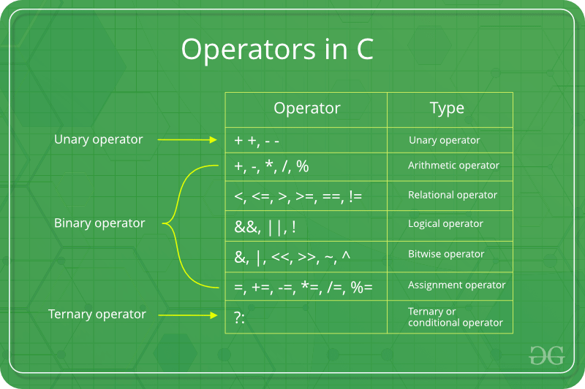

**Assignment Operators**

Assignment operators are used to assigning value to a variable. The left side operand of the assignment operator is a variable and right side operand of the assignment operator is a value. The value on the right side must be of the same data-type of the variable on the left side otherwise the compiler will raise an error.  
Different types of assignment operators are shown below:

* **“=”**: This is the simplest assignment operator. This operator is used to assign the value on the right to the variable on the left.  
  For example:

a = 10;

b = 20;

ch = 'y';

* **“+=”**: This operator is combination of ‘+’ and ‘=’ operators. This operator first adds the current value of the variable on left to the value on the right and then assigns the result to the variable on the left.  
  Example:

(a += b) can be written as (a = a + b)

If initially value stored in a is 5. Then (a += 6) = 11.

* **“-=”**This operator is combination of ‘-‘ and ‘=’ operators. This operator first subtracts the current value of the variable on left from the value on the right and then assigns the result to the variable on the left.  
  Example:

(a -= b) can be written as (a = a - b)

If initially value stored in a is 8. Then (a -= 6) = 2.

* **“*=”**This operator is combination of ‘*’ and ‘=’ operators. This operator first multiplies the current value of the variable on left to the value on the right and then assigns the result to the variable on the left.  
  Example:

(a *= b) can be written as (a = a * b)

If initially value stored in a is 5. Then (a *= 6) = 30.

* **“/=”**This operator is combination of ‘/’ and ‘=’ operators. This operator first divides the current value of the variable on left by the value on the right and then assigns the result to the variable on the left.  
  Example:

(a /= b) can be written as (a = a / b)

If initially value stored in a is 6. Then (a /= 2) = 3.

Below example illustrates the various Assignment Operators:

C++

// C++ program to demonstrate

// working of Assignment operators

#include <iostream>

using namespace std;

int main()

{

// Assigning value 10 to a

// using "=" operator

int a = 10;

cout << "Value of a is "<<a<<"\n";

// Assigning value by adding 10 to a

// using "+=" operator

a += 10;

cout << "Value of a is "<<a<<"\n";

// Assigning value by subtracting 10 from a

// using "-=" operator

a -= 10;

cout << "Value of a is "<<a<<"\n";

// Assigning value by multiplying 10 to a

// using "*=" operator

a *= 10;

cout << "Value of a is "<<a<<"\n";

// Assigning value by dividing 10 from a

// using "/=" operator

a /= 10;

cout << "Value of a is "<<a<<"\n";

return 0;

}

**Output**

Value of a is 10

Value of a is 20

Value of a is 10

Value of a is 100

Value of a is 10